|  |  |  |
| --- | --- | --- |
| Decision Tree | | |
|  |  |  |
| Prashanth.S 19MID0020 | | |

# Question-1

Taking the 10th record With age=senior and credit_rating=fair we are getting   
buys_computer = yes

# Question-2

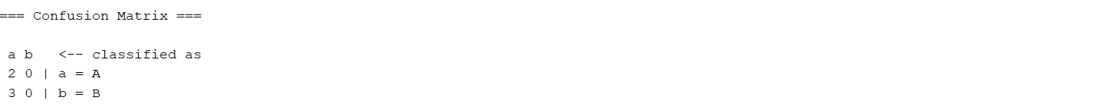

With income=high, the person belongs to the class A

# Question-3

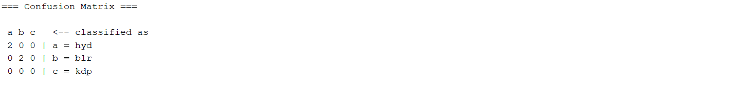

With the 2nd record Age=21, will get Location=hyd